Siemens S7-200CN decryption software instructions
This set of software is disassembled and decrypted. After many years of practice, this set of software has been proved to be feasible: You can interpret all the Siemens S7-200 PLC (imported, domestic CN type) passwords that have been sold in the market so far. The models include (212, 214). 216, 222, 22CN, 224, 224CN, 224XP, 224XP CN, 226, 226CN, 226XM) Easily cracking level 3 and POU passwords. It is the most advanced and practical decryption method so far. It directly reads the PLC's EEPROM chip to obtain the password. (Note: Currently there is no pure software available to understand the new version of Siemens S7-200CN. It must be disassembled to decrypt. If the seller says that there is no need to disassemble the device, please think twice before proceeding.)
We provide this set of software contains the following content: Software Download
- 1. CPU221.222.224.226CN bin file
2. EEPROM chip programmer
- S7-200CN Decrypted client program (more than 200 examples)
- S7-200CN Decryption software (domestic CN, new CPU 02.01)
- S7-200解密软件（老版本CPU型号）
- CPU 24CXX的拆机芯片示意图.JPG
- EEPROM芯片24Cxx管脚图.BMP
- EEPROM芯片编程器与PC电脑连接.JPG
- EEPROM芯片编程器与PC电脑直连.JPG
- EEPROM芯片中文编程器教程.rar
- S7-200CN 4级改3级的解密教程.doc
- s7-200cn 解密说明.jpg
- s7-200cpu EEPROM芯片图示.jpg
- 西门子S7-200CN解密软件使用说明.doc
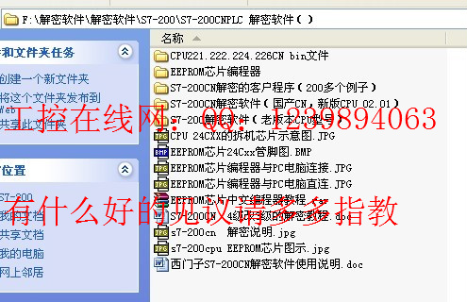
The first time to decrypt the conditional best to find a PLC experiment or we provide a program EEPROM chip 24C256 read data, according to the following process once. Do not behave in such a way as to avoid unforeseen problems. Below you need to bring 2 tools. The first one is a soldering iron or air gun, and the second one is a dice. The other is provided by us.
Before disassembling and decrypting, please use the programming software “STEP 7-MicroWIN” above Siemens 4.0 to read the PLC, firstly determine the encryption level of the PLC, and secondly determine the communication baud rate and PLC address of the PLC.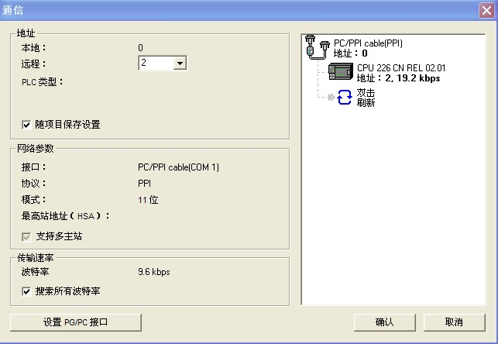
Look at this package of software decryption package "24CXX teardown chip map", then you according to Siemens PLC installation instructions to open the cover, remove the CPU board, find the 24CXX chip, remove the electric iron or air gun EEPROM chip comes. (Note: CPU221CN, CPU222 CN EEPROM chip is 24C64, CPU224 CN, CPU224XP CN EEPROM chip is 24C256, CPU226 CN, CPU226XP CN EEPROM chip is 24C512, other types of PLC can not disassemble decryption, decryption software has been downloaded for free
，download link：）
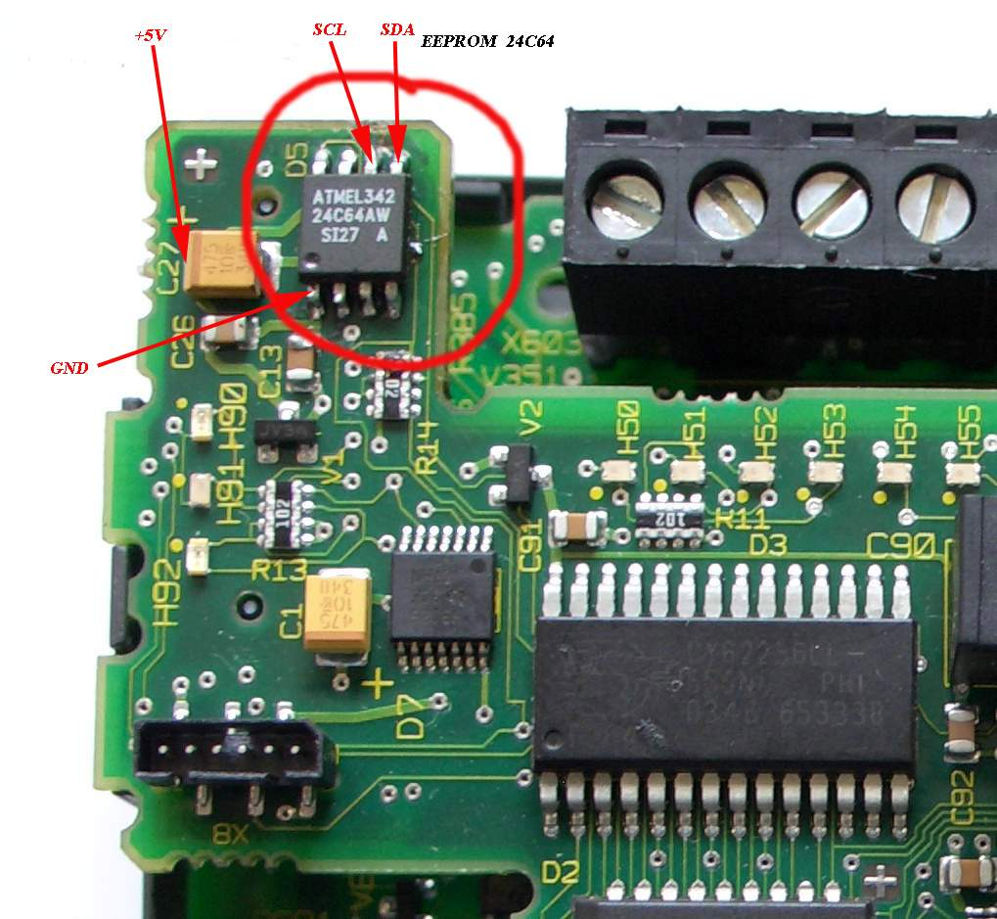
The next step is to start reading the EEPROM chip. Look at the figure below. The digital mark of the EEPROM chip pin should be inserted into the same digital mark on the programmer. Actually, the chip cannot be directly inserted into the programmer because the EEPROM chip is a patch. The chip is too small, so an 8-pin chip adapter is included. The EEPROM chip is placed directly on the chip adapter. Connect to the computer through the communication cable, as shown below: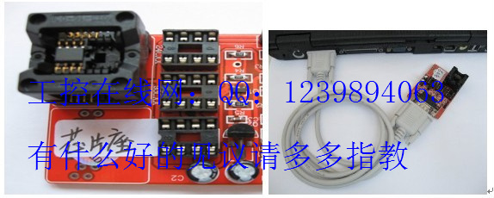
Now you can open the “setup.exe” installation program in the EEPROM chip programmer folder in the software package. After the installation is completed, you can open the “Chinese EEPROM chip Chinese programmer.exe”, according to the EEPROM chip Chinese programmer.exe The tutorial steps explain step-by-step operations! You have to choose the correct size and model of the chip, otherwise the file read out is wrong, and the decryption will fail. The specific size depends on the chip's logo, and you cannot click the wrong button. After reading the data, click Save as BIN file, keep it properly, in case of accident, you can read the device multiple times, save several times more BIN file。
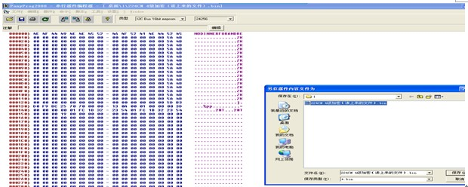

S7-200CN (new PLC) decryption is divided into 3 levels of decryption and 4 levels of decryption: Level 3 password cracking is relatively simple, after the chip reads the data and saves it as a BIN file, you can directly run the "S7- 200 disassemble decryption software" can display the password directly.
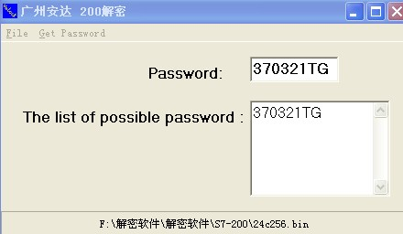

S7-200CN (new PLC) level 4 decryption is the key technology of CN decryption, we first look at the official statement of Siemens：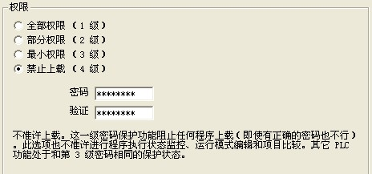

The new version of S7-200plc adds a fourth level of protection, which prohibits reading and writing, whether or not you know the password. Can not upload the program in the PLC. Cracking this encrypted PLC does have some difficulty. We crack the four-level password idea: Everyone knows that Siemens's programs are divided into program blocks, data blocks, and system blocks. The password is stored in the system block and is saved separately in the BIN file. However, if you read the password at level 4, you cannot upload the program, so change the level 4 to level 3 or lower, but if you only change the password protection level, then you have a question about the check code of the block. The error can not be uploaded by the program or uploaded to a blank program, and the PLC fault light reports an error. Can we replace the entire known 4-level encryption system block with the entire system block of known level 3 encryption, and the program block and data block are not moved. In this way, we can crack the level 4 encryption protection of the S7-200CN plc. This is the most convenient and easy way to crack Level 4 protection. It is also the only way to decrypt it easily.
Next we now need to find out where the system block is in the BIN file: where is the block position? Please install the "Hex Workshop 4.22" software in the running software package and run the "HWorkS32.exe" software in the installation directory. Open the level 4 BIN file that you just saved, and then open the level 3 file of the same model CPU model in the "BIN" tarball that is shipped with the package, for example, 224CN. Looking at the graph, you drag the mouse to select the data between **** and ****, then right-click in the selection area and click in the pop-up selection box. “copy”， 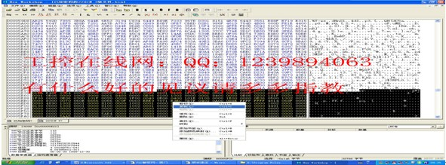
Then click to activate the level 4 BIN file you want to crack, find the same address, the data from the beginning of the **** to ****, remember that the replacement can only replace the same cpu with the version, and all the blocks The starting position is from ****, this is the law. You can now click on the selected data file in the level 4 password file and select "Paste" in the popup selection box.， 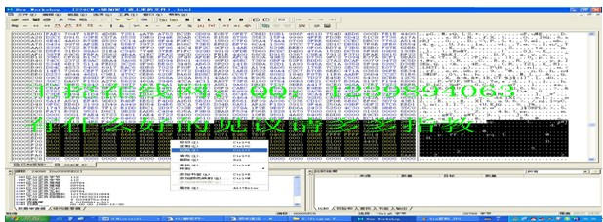

You can click save, the original level 4 file is replaced by the current level 3 file, rewrite 24C chip，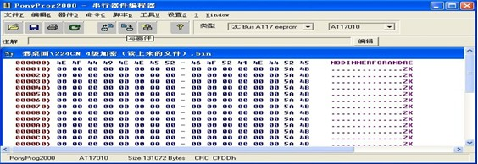
Then hot air gun welding, installation, power-up PLC at this time if there is no error can upload the program.
So far. S7-200CN (new PLC) level 4 encryption has been successfully cracked.
You are welcome to use our software. If you have any good comments, please give us your comments or leave a comment on QQ:1239894063. In addition, we also provide OMRON CQM1H/CP1L direct-read decryption software, do not need to disassemble decryption, read the password in one minute. The software diagram is as follows：
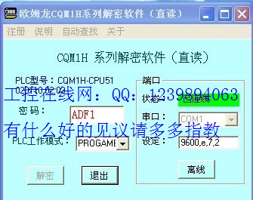详细说明与下载
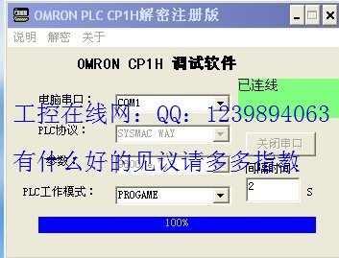
Detailed description and download

